INDIVIDUAL SHARED RESPONSIBILITY EXEMPTIONS
Frequently Asked Questions

Q. What is an exemption?
A. The Affordable Care Act (ACA) requires individuals to have health insurance coverage that qualifies as “minimum essential coverage” or pay a tax (also called the “individual shared responsibility payment”). However, under a few special circumstances, an individual may not have to pay the tax even though he or she did not have health insurance coverage for part or all of the year. This is referred to as an exemption from the individual shared responsibility payment.

Q. What types of health coverage qualify as “Minimum Essential Coverage”?
A. You do not need to apply for an exemption if you have health coverage that qualifies as “minimum essential coverage”. If you are covered by any of the following types of health coverage, you have “minimum essential coverage”:
• Any HSRI plan;
• Coverage purchased in the individual market;
• Most Medicaid coverage or CHIP (RIteCare);
• Medicare (Part A) coverage and Medicare Advantage Plans;
• Any employer plan (including COBRA), with or without “grandfathered”
status. This includes self-insured and retiree plans. Your employer has information on whether the health coverage offered is minimum essential coverage;
• TRICARE (for current service members and military retirees, their families,
and survivors);
• Veterans healthcare programs;
• Peace Corps Volunteer Plans;
• Self-funded health coverage offered to students by universities for plan or
policy years that begin on or before Dec. 31, 2014;
• Other plans may also qualify. Ask your health coverage provider for more
information.

Minimum essential coverage doesn’t include coverage providing only limited benefits, such as coverage only for vision care or dental care; and Medicaid covering only certain benefits such as family planning; workers' compensation; or disability policies.

Q. What kinds of exemptions are available and where do I apply?
A. Depending on the reason you’re requesting an exemption, you can apply for an exemption through HealthSource RI or on your federal tax return. You can learn more about this in the table below. We strongly encourage you to apply for an exemption with the IRS when filing your federal tax return, if possible.

If your income will be low enough that you won’t be required to file taxes, you don’t need to file a tax return to claim the coverage exemption. However, if you aren't required to file a tax return but choose to file anyway, you must claim the coverage exemption on your return.

Exemption Reason & Where to Apply | Application Timing
You must apply for the following Exemptions through HealthSource RI:
You’re a member of a recognized religious sect with religious objections to insurance, including Social Security and Medicare | You may apply at any time.
You have experienced a “hardship” that  affects your ability to purchase health insurance coverage | You may apply before, during or after  the hardship, depending on the circumstances. For more information about how long hardship exemptions may last, please visit: https://www.healthcare.gov/health-coverage-exemptions/hardship-exemptions/.
The lowest-priced coverage available to you in 2016 would cost more than 8.05% of your projected household income | You may apply for this exemption before the end of the 2016 plan year.. You must also have completed an application for coverage through HSRI.
You are encouraged to apply for the following Exemptions through the IRS when you
file your federal income tax return:
You’re a member of a federally recognized tribe or eligible for services through an  Indian Health Services provider | You may apply at any time.
You’re a member of a recognized healthcare sharing ministry | Generally speaking, you may only apply retrospectively which means you apply  for the year once it has ended and when you are filing your tax return.  If you are requesting an exemption for certain months during the current year that you will be a member in a health care sharing ministry you must apply through HealthSource RI.
You’re incarcerated, and not awaiting the disposition of charges against you | You may only apply retrospectively, which means you apply for the year only once it has ended and when you are filing your tax return.
You must apply for the following Exemption through the IRS when you file your Federal Income Tax Return:

You were uninsured for less than 3 consecutive months during the year | You may apply only when you file your taxes.
The minimum amount you would have paid for health insurance premiums in 2015 is more than 8.05% of your household income. | You may apply only when you file your taxes.
Individuals not required to file taxes but who filed anyway and have income above the filing threshold | You may apply only when you file your taxes
Individuals who lack affordable coverage when the cost of self‐only plans are combined | You may apply only when you file your taxes.
Citizens living abroad and certain noncitizens | You may apply only when you file your taxes.
Your household income was below  138% of the federal poverty line for your family size and at any time in 2015 you resided in a state that didn't participate in the Medicaid expansion under the Affordable Care Act. | You may apply only when you file your 2015 taxes.
During 2015 a child was added to your  tax household by birth or adoption, or a member of your tax household died during the year, and you can't check the full­year coverage checkbox on your tax return. | You may apply only when you file your 2015 taxes.

Q. How do I apply for an exemption through HealthSource RI?
A. Again, you are encouraged to apply for an exemption through the IRS when you file your federal income taxes, if possible. To apply for an exemption based on hardship, membership in a recognized religious sect that objects to insurance, membership in a federally-recognized tribe, coverage being unaffordable, incarceration, or membership in a healthcare sharing ministry, and you do not have the option of submitting an application to the IRS when you file your federal income taxes, you may complete and submit the exemption application form in your account. You can obtain an application form by logging in to your account at HealthSourceRI.com, clicking on “Tasks”, then clicking on “Apply for an Exemption”.

Q. Where can I find more information on how to apply for an exemption on my tax return?
A. You can find more information about how to apply for an exemption on your tax return, here http://www.irs.gov/Affordable-Care-Act/Individuals-and-Families/ACA-Individual-Shared-Responsibility-Provision-Exemptions.

Q. What materials do I need to apply for an exemption?
A. You will need to include documents that support your claim if you are applying for an exemption through HealthSource RI. If you are applying for a hardship exemption, you must provide the document(s) that are from the same time period as the hardship you experienced. Please refer to the tables below for a list of approved documentation.

If you are applying for an exemption through the IRS and you can’t obtain the documents you need to support your claim or need other assistance, call the Health Insurance Marketplace Call Center at
1-800-318-2596. If applying for an exemption through HealthSource RI and you can’t obtain appropriate documents, call HealthSource RI at 1-855-840-4774.

Exemption Reason | Documentation Required
You are a member of a recognized religious sect with religious objections to insurance, including Social Security and Medicare | The name and address of the religious sect.  If available, a copy of an approved IRS Form 4029 (“Application for Exemption from Social Security and Medicare Taxes and Waiver of Benefits”).
You are a member of a recognized healthcare sharing ministry | The name and address of the healthcare- sharing ministry.
You were incarcerated | Documents showing the name and address of the facility where you were incarcerated, and the time periods of incarceration.
You are a member of a federally recognized tribe or eligible for services through an Indian Health Services provider | Documents showing tribal membership or eligibility for services from the Indian Health Service, a tribal health care provider, or an urban Indian healthcare provider.
You’ve experienced a hardship that prevented you from purchasing health insurance | See hardship reasons in table below.
The lowest-priced health coverage available to you in 2016 is more than 8.05% of projected household income | Application ID from HealthSource RI or information about any job-related health insurance available to family. Lowest price plan available.

There are particular documentation requirements for hardship exemptions:

Hardship Reason | Documentation Required
You were homeless. | None.
You were evicted in the past 6 months or were facing eviction or foreclosure. | Copy of eviction or foreclosure notice.
You received a shut-off notice from a utility company. | Copy of shut-off notice from a utility company or proof of more than 6  months behind on payments if utility can't shut off (for reasons of medical necessity or hardship).
You recently experienced domestic violence. | None
You recently experienced the death of a close family member. | Copy of death certificate, copy of death notice from newspaper, or copy of official notice of death.
You experienced a fire, flood, or other natural or human-caused disaster that caused substantial damage to your property. | Copy of police or fire report, insurance claim, or other document from government agency, private entity, or news source documenting event.
You filed for bankruptcy in the last 6 months. | Copy of bankruptcy filing.
You had unreimbursed medical expenses in the last 24 months that resulted in substantial debt. | Copies of medical bills.
You experienced unexpected increases in necessary expenses due to caring for an ill, disabled, or aging family member. | Copies of receipts related to care.
You expect to claim as a tax dependent a child who’s been denied coverage in Medicaid and the Children’s Health Insurance Program (CHIP), and another person is required by court order to give medical support to the child. | Copy of medical support order AND copies of eligibility notices for Medicaid and CHIP showing that the child has been denied coverage. Exemption is only for the months the medical support order is in effect.
As a result of an eligibility appeals decision,  you’re eligible either for: 1) enrollment in a qualified health plan (QHP) through HealthSource RI, 2) lower costs on your monthly premiums,  or 3) cost-sharing reductions for a time period when you weren’t enrolled in a QHP through HealthSource RI. | Copy of notice of appeals decision.
You received a notice saying your individual insurance plan was cancelled after June 30, 2013 and you consider the other available plans unaffordable. | Copy of notice of cancellation.

Q. How do I determine whether insurance is “unaffordable” for me?
A. Insurance is unaffordable if both the coverage offered through your employer, and the lowest cost bronze plan offered through HealthSource RI, would cost more than 8% of your income. If any of those options cost 8.05% or less of your income, health insurance is considered affordable to you and you do not qualify for this exemption.
Example: Your household annual income in 2015 was $50,000.00. The annual cost of your employer-sponsored coverage was $4,500.00. The annual cost of the "lowest cost Bronze plan" available to you was $5,000.00. Because both options exceed 8.05% of your household income ($4,000.00), you are eligible for a penalty exemption.

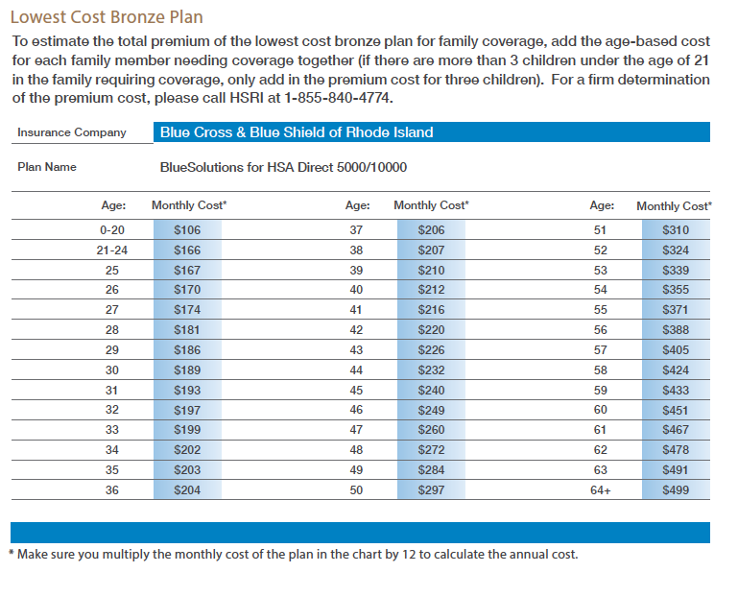

If you believe your 2015 health insurance was unaffordable for you, you need to apply for this exemption in your 2015 tax return.

Do not to confuse the 8.05% Exemption Test with the 9.5% threshold for Tax Credit Eligibility. To be eligible for Advanced Premium Tax Credits (APTCs), an individual must not have the option of enrolling in affordable employer sponsored health insurance. Employer health insurance coverage is unaffordable if the cost for employee-only coverage is 9.5% of “household income” or greater. Under this test, individuals may qualify for a tax credit to purchase a plan through HealthSource RI if their household income is between 100-400% of the Federal Poverty Level (FPL), the individual is not eligible for government-offered healthcare (e.g., Medicare, Medicaid, or RIteCare), and employer-sponsored coverage is unaffordable to them.

Q. How long does it take HealthSource RI to process an exemption application?
A. The time HealthSource RI needs to process an exemption application will vary depending on the complexity of the exemption requested, whether the application is missing any information, and whether additional supporting documentation is required. If additional information is needed, the process could take longer.

Once again, we encourage you to apply for an exemption through the IRS when you file your taxes, if possible. If you must apply through HealthSource, please submit the required documentation with your application. You will receive an eligibility determination notice in the mail when the application has been processed. If your request has been approved, your notices will include an exemption certification number. You should retain this number for your records because you will need it when you file your federal taxes for the year.

Completed applications can either be submitted by logging into your account at HealthSourceRI.com or can be mailed to:

HealthSource RI
Hazard Building Mailroom
74 West Road, Suite 500
Cranston, RI 02920-8409

Q. If I am granted a hardship exemption, how long will it last?
A. The duration of an exemption differs based on the type of exemption requested. Hardship exemptions may be claimed for the months during which the hardship existed (including the month before the hardship, the months of the hardship, and the month after the hardship), however, HealthSource RI may provide the exemption for additional months after the hardship, including up to a full calendar year, if the hardship continues to affect the customer.

Q. What if I think the results of my application are wrong?
A. If you applied for an exemption with the IRS when you filed your taxes and don’t agree with the results of your application, you can appeal the decision by calling 1-800-318-2596. A request can also be made in writing to the Health Insurance Marketplace – Exemption Processing at 455 Industrial Blvd., London, KY 40741.

If you applied for an exemption through HealthSource RI and don’t agree with the results of your application, you can appeal the decision by calling HealthSource RI at 1-855-840-4774 or visiting HealthSourceRI.com and appealing through your account.

Requesting an appeal is time sensitive. You must request your appeal within 30 days of the receipt of your notice. Please review your eligibility notice to find appeals instructions specific to each person in your household, including the timeframe in which each person can request an appeal.

Q. What happens if I’m not exempt?
A. If you are not exempt, the penalty for not having insurance is either a set amount of money or a percentage of your income—whichever is greater. For more information on the penalty please visit,
http://www.irs.gov/Affordable-Care-Act/The-Individual-Shared-Responsibility-Payment-An-Overview

