

***How to*Use the HealthSource RI**

**Income Calculator  
  
  
HEALTHSOURCE RI FACTS & DATES**

**HealthSource RI Contact Center**

**1-855-840-4774/*HealthSourceRI.com***

**Introduction**

HealthSource RI offers an income calculator to help you estimate your income. It’s important that you calculate this number correctly because it is used to determine whether you qualify for financial help to pay for your health insurance.

**Important notes:**

* The calculator only asks about you and your income. If there are multiple people in your household earning money, you should use this calculator to calculate their income too.
* The calculator will not auto-fill your income into the HealthSource RI application. Be sure to write down your total income or copy and paste it into your application.
* If the calculator gives you a total income that doesn’t match what you think you’ll earn in 2015, you can put your best estimate into your application. Just be aware that your estimate won’t reflect all the detailed questions in the calculator.

You’ll start with this screen, where you’ll check off all of your sources of income and possible deductions.

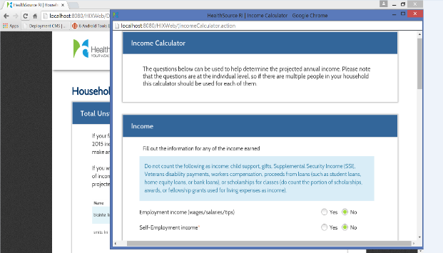



***How to*Use the HealthSource RI**

**Income Calculator  
  
  
HEALTHSOURCE RI FACTS & DATES**

**Income**

For every type of income you select, a box will open asking you for more information. If you clicked every type of income, these are all the boxes you would see. The next pages explain each part of the screen, letter by letter.

A

B

C

D

E

F

G

H

I

J

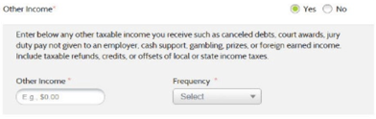

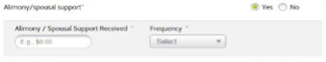

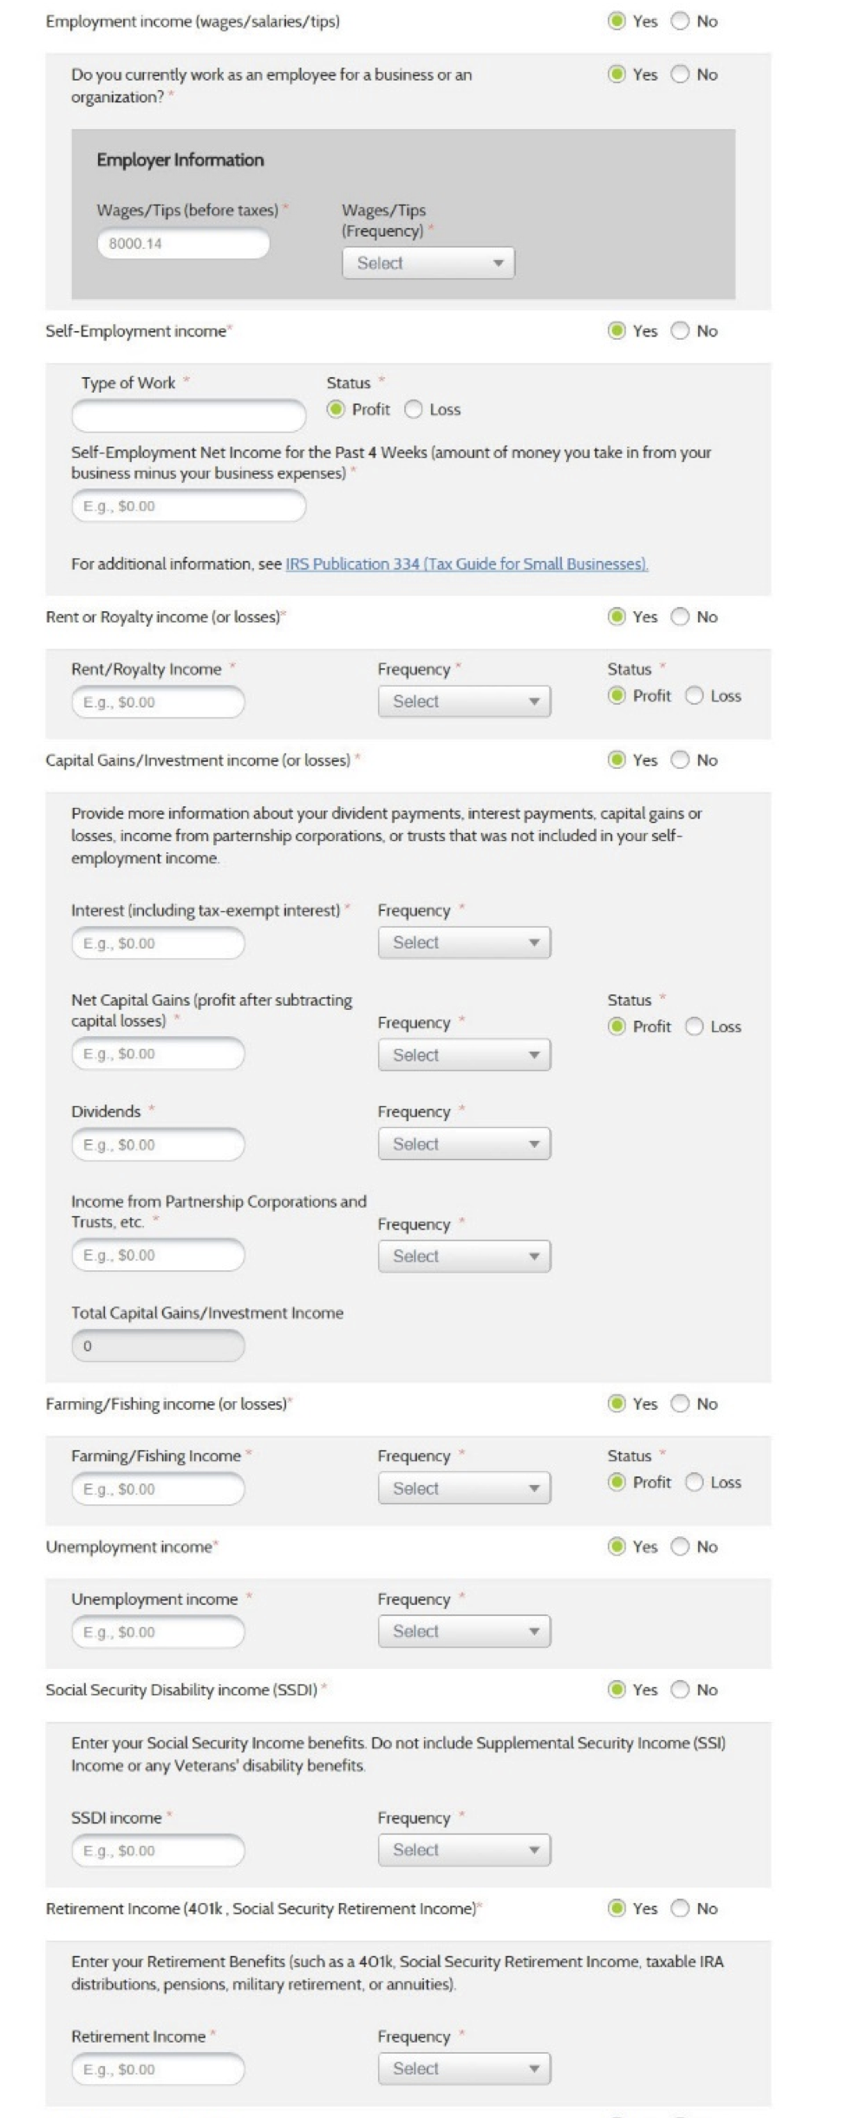



***How to*Use the HealthSource RI**

**Income Calculator  
  
  
HEALTHSOURCE RI FACTS & DATES**

**Income**

Here’s how to fill out each section:

**A: Employment Income**

Enter any wages, tips or salary that you received while working as an employee for an employer. Use the “frequency” drop-down menu to tell us whether this is your yearly, monthly, weekly or hourly income.

**B: Self-Employment Income**

Enter any income you earned working for yourself over the past 4 weeks. This is the amount of money you brought in minus your business expenses. If you lost money in the last 4 weeks, enter in that amount and click the “loss” button. Do not add a “minus” symbol.

**C: Rent or Royalty Income**

Enter any rental or royalty income. Use the “frequency” drop-down menu to tell us whether you receive this income yearly, monthly or weekly. If you lost income, enter that amount and select the “loss” button.

**D: Capital Gains or Investment Income**

Enter any income you’ve gained through interest, net capital gains, partnership corporations or trusts. If you have capital losses, just enter that amount and click the “loss” button.

**E: Farming or Fishing Income**

Enter any income you’ve gained from fishing or farming. Use the “frequency” drop-down menu to tell us whether you receive this income yearly, monthly or weekly. If you’ve lost income, enter that amount and select the “loss” button.

**F: Unemployment Income**

If you’re on unemployment, tell us how much money you receive. Use the “frequency” drop-down menu to tell us whether this amount is weekly, monthly or yearly.



***How to*Use the HealthSource RI**

**Income Calculator  
  
  
HEALTHSOURCE RI FACTS & DATES**

**Income**

**G: Social Security Disability Income (SSDI)**

If you’re on SSDI, tell us how much money you receive. Use the “frequency” drop-down menu to tell us whether this amount is weekly, monthly or yearly. This field is only for SSDI. If you receive Supplemental Security Income (SSI), do not add it into this box.

**H: Retirement income**

If you’re receiving income from a retirement account (such as a 401k, Social Security, a pension, taxable IRA, or other retirement benefits) enter that income here. Use the “frequency” drop-down menu to tell us whether this amount is weekly, monthly or yearly.

**I: Alimony/spousal support**

If you’re receiving alimony or spousal support enter that income here. Use the “frequency” drop-down menu to tell us whether this amount is weekly, monthly or yearly.

**J: Other income**

Did we miss anything? If you are receiving income from another source that we didn’t ask about, enter it here. Use the “frequency” drop-down menu to tell us whether this amount is weekly, monthly or yearly.



***How to*Use the HealthSource RI**

**Income Calculator  
  
  
HEALTHSOURCE RI FACTS & DATES**

A

B

C

D

E

F

G

H

I

J

K

L

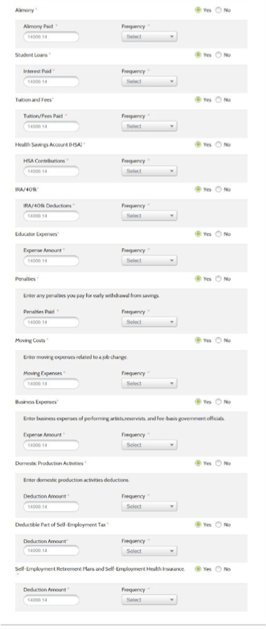

**Deductions**

The second set of boxes will ask you about your deductions, or expenses you’ve paid that will reduce your total household income. For every deduction you select, a box will open asking you for more information. If you clicked every type of deduction, these are all the boxes you would see. The next pages explain each part of the screen, letter by letter.



***How to*Use the HealthSource RI**

**Income Calculator  
  
  
HEALTHSOURCE RI FACTS & DATES**

**Deductions**

Here’s how to fill out each section:

**A: Alimony**

If you are paying alimony to a former spouse, enter it here. Use the “frequency” drop down-menu to tell us whether this amount is weekly, monthly or yearly.

**B: Student Loans**

If you have student loans, enter how much you spend paying off those loans. Use the “frequency” drop-down menu to tell us whether this amount is weekly, monthly or yearly.

**C: Tuition and Fees**

If you are paying for tuition or other fees associated with going to school, enter how much you spend here. Do NOT include the cost of personal, living, or family expenses such as room and board. Use the “frequency” drop-down menu to tell us whether this amount is weekly, monthly or yearly. For more information about which fees qualify, see advice from the IRS here- www.IRS.gov/publications/p970/ch06.html

**D: Health Savings Accounts (HSAs)**

If you have a Health Savings Account (HSA) to pay for your medical expenses, enter how much money you put into that account. Use the “frequency” drop-down menu to tell us whether this amount is weekly, monthly or yearly. For more information about HSAs, see the frequently asked questions on our website at HealthSourceRI.com.

**E: IRA/401K Deductions**

If you make contributions to an IRA or a 401k retirement account, enter in the amount you put into those accounts. Use the “frequency” drop-down menu to tell us whether this amount is weekly, monthly or yearly.



***How to*Use the HealthSource RI**

**Income Calculator  
  
  
HEALTHSOURCE RI FACTS & DATES**

**Deductions**

**F: Educator Expenses**

If you are a “qualified educator” and are not reimbursed for items you buy for your school (such as books, supplies and computer equipment), enter how much you spend on those items here. The most you can deduct is $250 for yourself or $500 if your spouse is also a qualified educator. Use the “frequency” drop-down menu to tell us whether this amount is weekly, monthly or yearly.

**G: Penalties**

If you had to pay a penalty or fine because you were late completing a contract or you did not complete that contract, enter the cost of that penalty here. You cannot deduct any penalties or fines you paid for violating the law.

**H: Moving Costs**

If you moved because of a change in your job or business location, or because you started a new job or business AND the move qualifies under the IRS definition of moving expenses, enter the amount you spent on moving here. For more information about if your expenses qualify, see the IRS definition of moving expenses here: www.irs.gov/taxtopics/tc455.html

**I: Business Expenses**

If you’ve spent money on qualifying expenses for your business, enter those total business expenses here. Do no include any expenses already deducted from your self-employment income that you entered in the calculator. For more information about expenses that qualify, see advice from the IRS here: [www.irs.gov/Businesses/Small-Businesses-&-Self-Employed/Deducting-Business-Expenses](http://www.irs.gov/Businesses/Small-Businesses-&-Self-Employed/Deducting-Business-Expenses)

**J: Domestic Production Activities**

If you deduct costs associated with domestic production activities on your taxes, enter that amount here.



***How to*Use the HealthSource RI**

**Income Calculator  
  
  
HEALTHSOURCE RI FACTS & DATES**

**Deductions**

**K: Deductible part of self-employment tax**

If you are self employed, enter the deductible portion of your self employment tax here.

**L: Self-employment retirement plans and self-employment Health Insurance**

If you are self-employed, and you buy your own health insurance or pay for your own retirement plan, enter the amount you spend here.

**Net Annual Income**

After providing all income details, the income calculator will provide your net annual income (total income minus any deductions) based on the information you provided.

